Chapter 12

Exercise Solutions

Ex 12.1
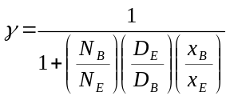
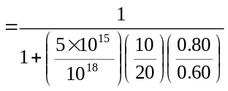
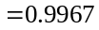
_______________________________________

Ex 12.2
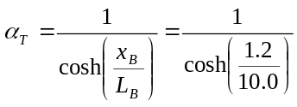
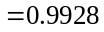
_______________________________________

Ex 12.3
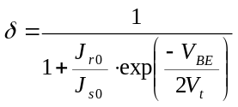
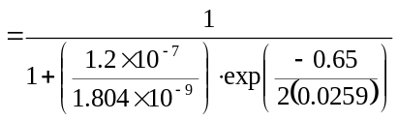
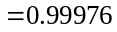
_______________________________________

Ex 12.4
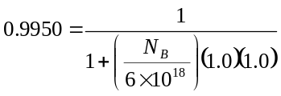
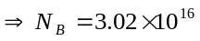cm
_______________________________________

Ex 12.5
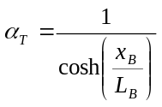
From Example 12.5, 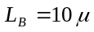m.
Then
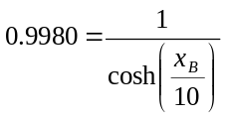
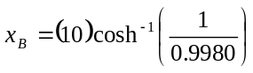
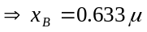m
_______________________________________

Ex 12.6
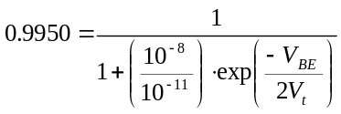
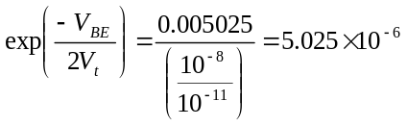
or
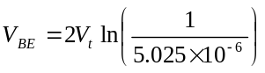
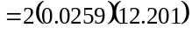
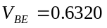V
_______________________________________

Ex 12.7
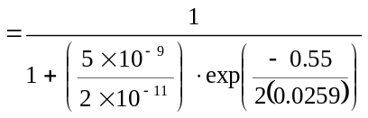
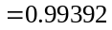

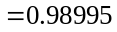
Then 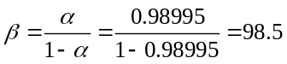
- 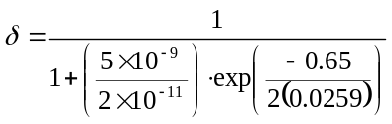
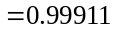
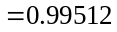
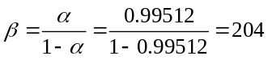
_______________________________________

Ex 12.8
The space charge width extending into the base region is
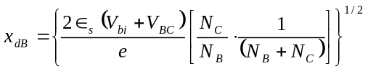
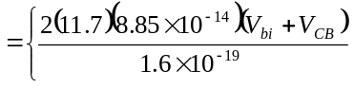
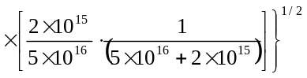
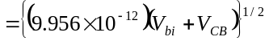
Now 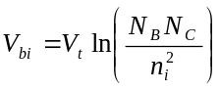
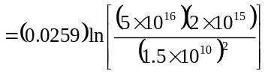
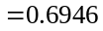V
For 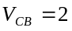V,
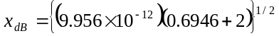
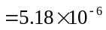cm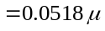m
For 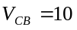V,
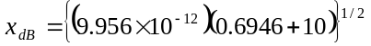
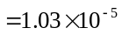cm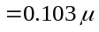m
Neglecting the B-E space charge width, we find the neutral base width to be:
V,
m
V,
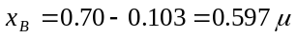m
_______________________________________

Ex 12.9
Neglecting bandgap narrowing,
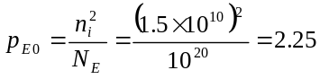cm
From Figure 12.26, 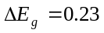eV for
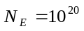cm,
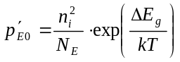
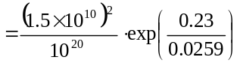
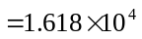cm
_______________________________________

Ex 12.10
- 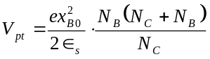
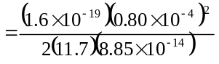
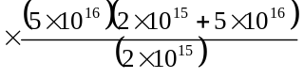
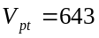V
- From Figure 7.15, 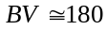V
_______________________________________

Ex 12.11
- From Figure 7.15, 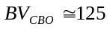V
- 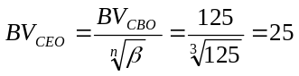V
_______________________________________

Ex 12.12
We find
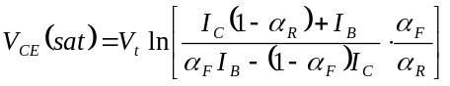
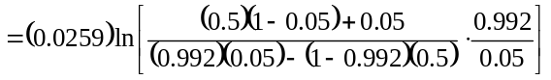 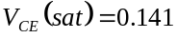V
_______________________________________

Ex 12.13
We have 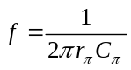
Or 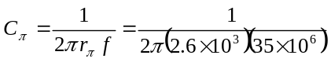
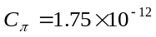F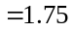pF
_______________________________________

Ex 12.14
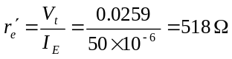
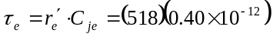
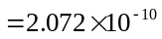s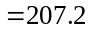ps
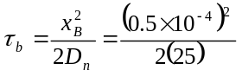
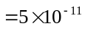s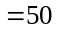ps
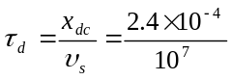
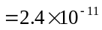sps
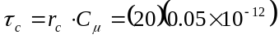
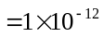sps
Now
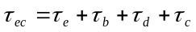
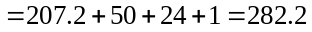ps
Then
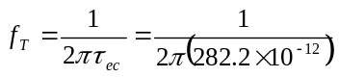
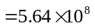Hz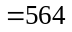MHz
Also
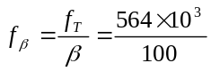
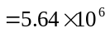Hz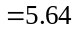MHz
_______________________________________

Test Your Understanding Solutions

TYU 12.1
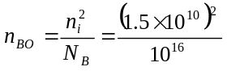
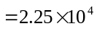cm
- 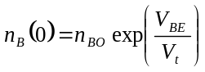
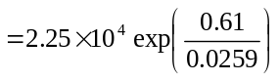
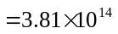cm
- Using Equation (12.15a), we find
At 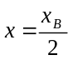, 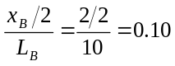
Then
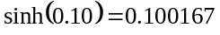
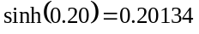
So
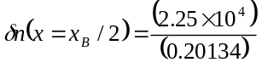
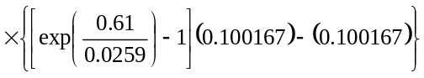 or
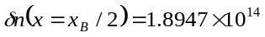cm
- For an ideal linear function
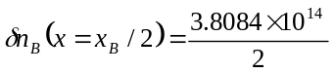
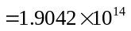cm
Ratio 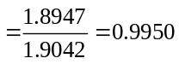
_______________________________________

TYU 12.2
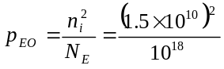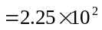cm
- 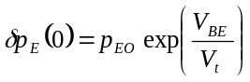
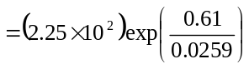
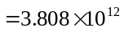cm

- We have
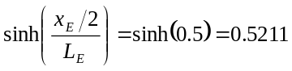
and
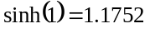
Then, using Equation (12.21a),
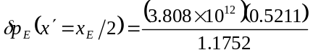
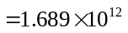cm
_______________________________________

TYU 12.3
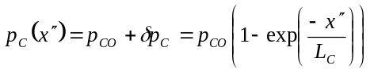
Then
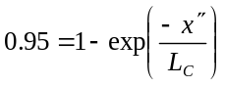
or
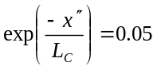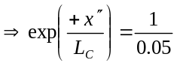
so
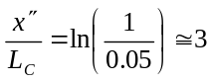
_______________________________________

TYU 12.4
We have 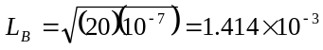cm
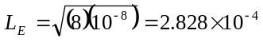cm
Now
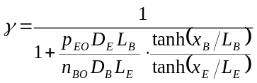
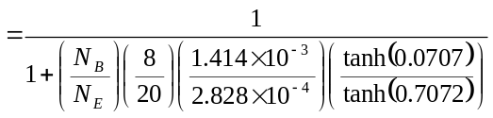
or
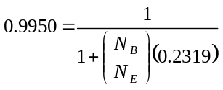
which yields
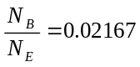
or 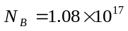cm
_______________________________________

TYU 12.5
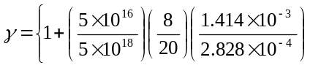
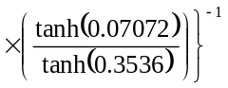
or 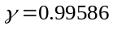
Then
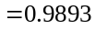
Now
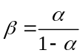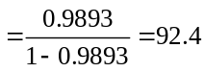
_______________________________________

TYU 12.6
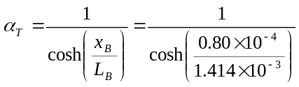
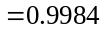
Then
Now
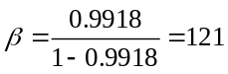
_______________________________________

TYU 12.7
- 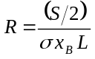
We find
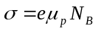
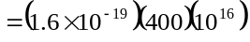
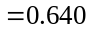(-cm)
Then
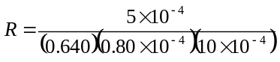
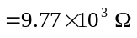
- 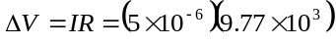
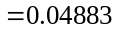V
or 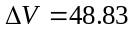mV

- 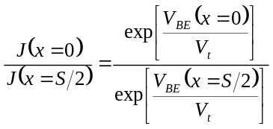
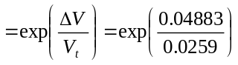
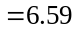
_______________________________________

TYU 12.8
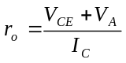
or
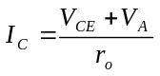
Now
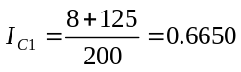mA
and
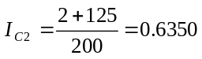mA
Then
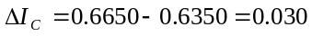mA
or
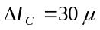A
_______________________________________

TYU 12.9
For 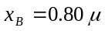m, 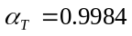
For 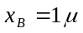m, 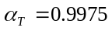
So
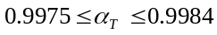
- 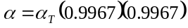
So that
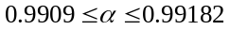
Then
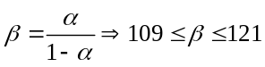
_______________________________________

TYU 12.10
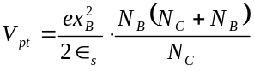
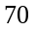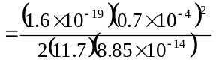
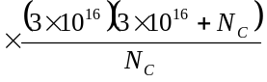
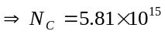cm
_______________________________________

